In LAB: 1. Implement R-S Latch in Verilog and simulate

Code: `timescale 1ns / 1ps

//////////////////////////////////////////////////////////////////////////////////

// Company:

// Engineer:

//

// Create Date: 18:48:05 05/01/2018

// Design Name:

// Module Name: RSLatch

// Project Name:

// Target Devices:

// Tool versions:

// Description:

//

// Dependencies:

//

// Revision:

// Revision 0.01 - File Created

// Additional Comments:

//

//////////////////////////////////////////////////////////////////////////////////

module RSLatch(

input R,

input S,

output Q,

output NQ

);

nor(Q, R, NQ);

nor(NQ, S, Q);

endmodule

Test Code:

`timescale 1ns / 1ps

////////////////////////////////////////////////////////////////////////////////

// Company:

// Engineer:

//

// Create Date: 18:49:49 05/01/2018

// Design Name: RSLatch

// Module Name: /tmp/tmp.TbiQs2mH3q/RSLatch/RSLatch_test.v

// Project Name: RSLatch

// Target Device:

// Tool versions:

// Description:

//

// Verilog Test Fixture created by ISE for module: RSLatch

//

// Dependencies:

//

// Revision:

// Revision 0.01 - File Created

// Additional Comments:

//

////////////////////////////////////////////////////////////////////////////////

module RSLatch_test;

// Inputs

reg R;

reg S;

// Outputs

wire Q;

wire NQ;

// Instantiate the Unit Under Test (UUT)

RSLatch uut (

.R(R),

.S(S),

.Q(Q),

.NQ(NQ)

);

initial begin

// Initialize Inputs

R = 0;

S = 0;

// Wait 100 ns for global reset to finish

#100;

// Add stimulus here

R = 1; S = 0;

#100 R = 0; S = 1;

#100 R = 0; S = 0;

#100 R = 1; S = 1;

end

endmodule

실행 결과:

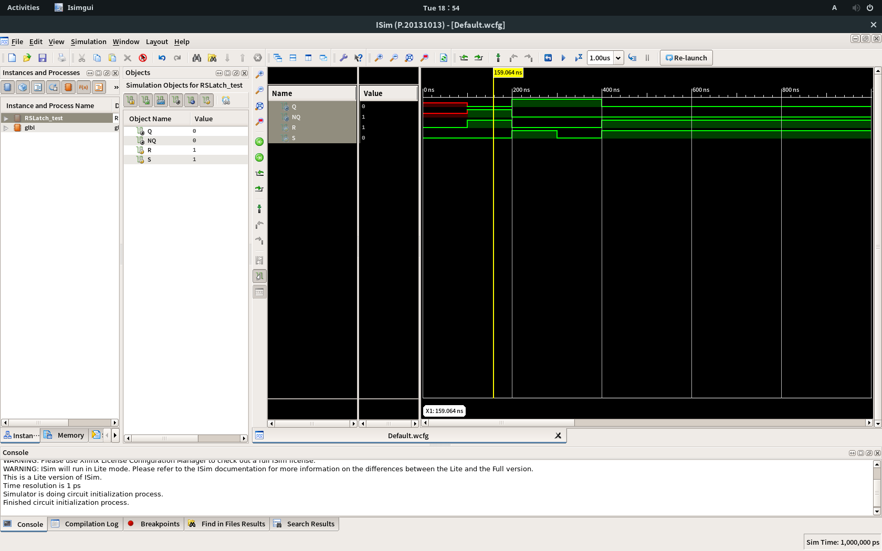

2. Implement gated R-S Latch in Verilog and simulate

Code: `timescale 1ns / 1ps

//////////////////////////////////////////////////////////////////////////////////

// Company:

// Engineer:

//

// Create Date: 18:55:28 05/01/2018

// Design Name:

// Module Name: GatedRSLatch

// Project Name:

// Target Devices:

// Tool versions:

// Description:

//

// Dependencies:

//

// Revision:

// Revision 0.01 - File Created

// Additional Comments:

//

//////////////////////////////////////////////////////////////////////////////////

module GatedRSLatch(

input R,

input E,

input S,

output Q,

output NQ

);

wire TR, TS;

and(TR, R, E);

and(TS, S, E);

nor(Q, TR, NQ);

nor(NQ, TS, Q);

endmodule

Test Code:

`timescale 1ns / 1ps

////////////////////////////////////////////////////////////////////////////////

// Company:

// Engineer:

//

// Create Date: 18:56:51 05/01/2018

// Design Name: GatedRSLatch

// Module Name: /tmp/tmp.TbiQs2mH3q/RSLatch/GatedRSLatch_test.v

// Project Name: RSLatch

// Target Device:

// Tool versions:

// Description:

//

// Verilog Test Fixture created by ISE for module: GatedRSLatch

//

// Dependencies:

//

// Revision:

// Revision 0.01 - File Created

// Additional Comments:

//

////////////////////////////////////////////////////////////////////////////////

module GatedRSLatch_test;

// Inputs

reg R;

reg E;

reg S;

// Outputs

wire Q;

wire NQ;

// Instantiate the Unit Under Test (UUT)

GatedRSLatch uut (

.R(R),

.E(E),

.S(S),

.Q(Q),

.NQ(NQ)

);

initial begin

// Initialize Inputs

R = 0;

E = 0;

S = 0;

// Wait 100 ns for global reset to finish

#100;

// Add stimulus here

R = 1; S = 0;

#100 R = 0; S = 1;

#100 R = 0; S = 0;

#100 R = 1; S = 1;

#100 E = 1; R = 0; S = 0;

#100 R = 1; S = 0;

#100 R = 0; S = 1;

#100 R = 0; S = 0;

#100 R = 1; S = 1;

end

endmodule

실행 결과:

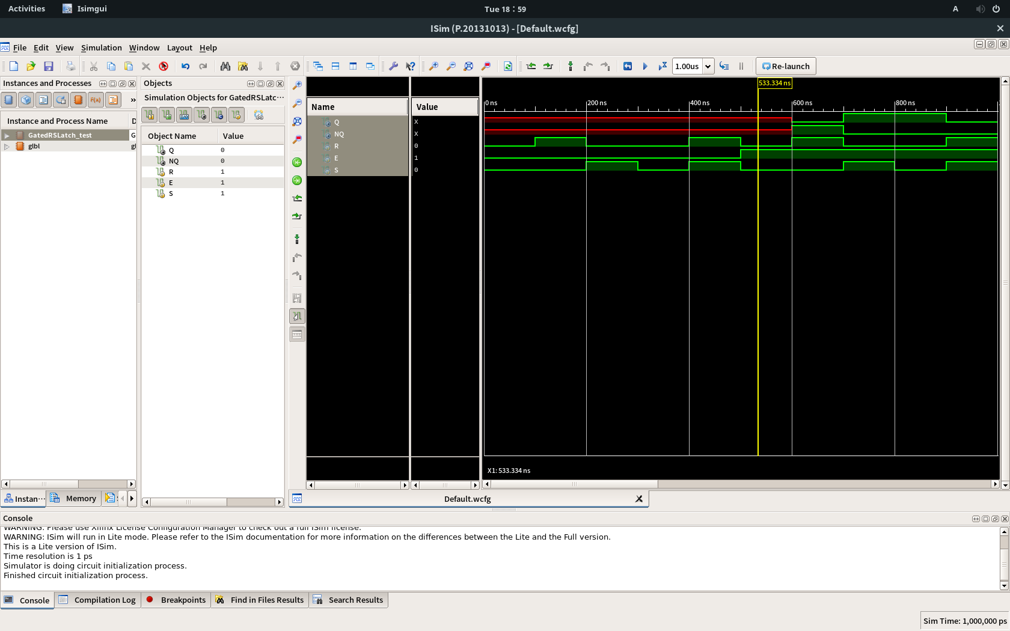

3. Implement simple oscillator in Verilog and simulate

Code:

`timescale 1ns / 1ps

//////////////////////////////////////////////////////////////////////////////////

// Company:

// Engineer:

//

// Create Date: 19:12:49 05/01/2018

// Design Name:

// Module Name: Oscillator

// Project Name:

// Target Devices:

// Tool versions:

// Description:

//

// Dependencies:

//

// Revision:

// Revision 0.01 - File Created

// Additional Comments:

//

//////////////////////////////////////////////////////////////////////////////////

module Oscillator(

input E,

output F

);

wire tmp;

assign tmp = E&F;

assign #5 F = !tmp;

endmodule

Test Code:

`timescale 1ns / 1ps

////////////////////////////////////////////////////////////////////////////////

// Company:

// Engineer:

//

// Create Date: 19:14:50 05/01/2018

// Design Name: Oscillator

// Module Name: /tmp/tmp.TbiQs2mH3q/RSLatch/Oscillator_test.v

// Project Name: RSLatch

// Target Device:

// Tool versions:

// Description:

//

// Verilog Test Fixture created by ISE for module: Oscillator

//

// Dependencies:

//

// Revision:

// Revision 0.01 - File Created

// Additional Comments:

//

////////////////////////////////////////////////////////////////////////////////

module Oscillator_test;

// Inputs

reg E;

// Outputs

wire F;

// Instantiate the Unit Under Test (UUT)

Oscillator uut (

.E(E),

.F(F)

);

initial begin

// Initialize Inputs

E = 0;

// Wait 100 ns for global reset to finish

#100;

// Add stimulus here

E = 1;

end

endmodule

실행 결과:

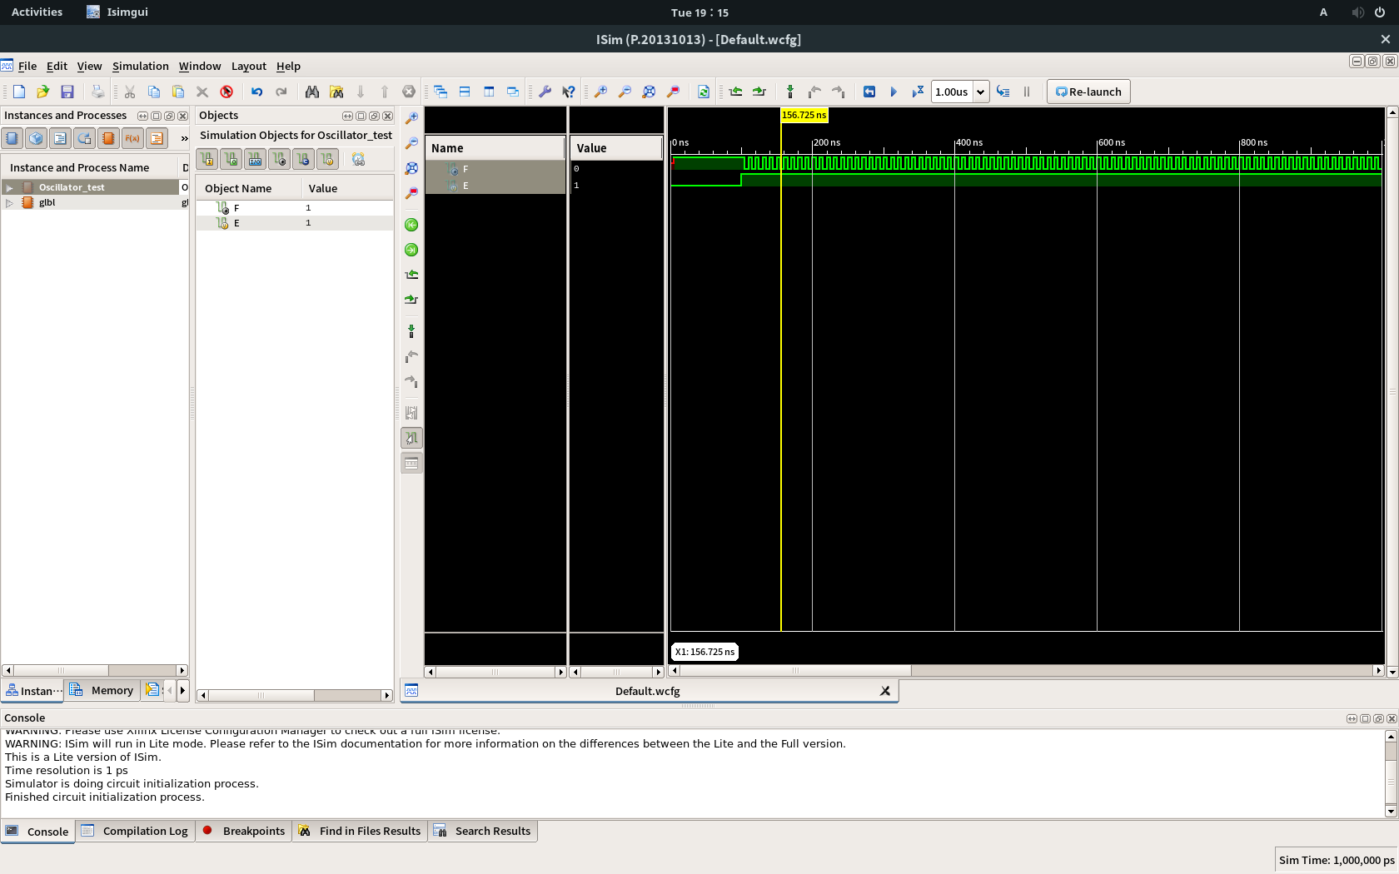

Homework: No Homework!